INSTRUCTIONS

There are two options for accessing your email at Bristol including (1) Outlook on your desktop and (2) Office 365 Outlook accessed online within accessBCC (or at office365.bristolcc.edu). You will need to create your signature for each method that you use. Please note that signatures with graphics are not currently available on an iPhone (iOS) or any Android-based phone.

Desktop Outlook (your office computer)
- File, Options, Mail tab, Signatures button, see Create your Signature below.

Office 365 Outlook (through accessBCC or at office365.bristolcc.edu)
- For the initial set up, you will need to use Internet Explorer in order for all the links and graphics to copy properly.
- Click Settings (cog wheel) in the upper right corner, Mail link (toward the bottom), under Layout (left panel), click Email Signature, see Create your Signature below. Remember to save your changes.

Create your Signature
Simply copy and paste the email signature block below into the email signature option of Outlook, then customize each field with your information. Please note:

- Your direct phone number (not 508… ext.1234) is preferred in the first position on the third line.
- Dept./Fax/Cell are options for the second contact number.
- LinkedIn is optional (create a hyperlink to your account page).
- Social media handles/links can be inserted if it is a professional account. Use the | symbol to separate items. Use two spaces before and after the symbol for improved legibility.
- “Proud to be…” line is optional for faculty/staff who are also Bristol alumni and are participating in the Connect2Bristol platform. Simply delete the line after pasting the block into the signature window in Outlook if you do not wish to include it.
- The logo/locations image already contains a hyperlink to BristolCC.edu. Please do not edit or remove this image.
- DO NOT ADD YOUR OWN LOGO OR GRAPHIC.

Please contact the College Communications team if you have any questions.

EMAIL SIGNATURE

John Fornoff | Publications Specialist, College Communications
Bristol Community College | 777 Elsbree Street, Fall River, MA 02720 | D102
774.357.2560 direct | 774.357.2169 dept. | LinkedIn

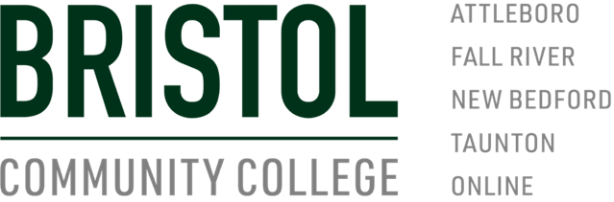

EMAIL SIGNATURE FOR BRISTOL ALUMNI

John Fornoff | Publications Specialist, College Communications
Bristol Community College | 777 Elsbree Street, Fall River, MA 02720 | D102
774.357.2560 direct | 774.357.2169 dept. | LinkedIn

Proud to be a Bristol graduate! Connect with me on Connect2Bristol.org

